NAMUNGOONA SALAF SEC SCH.
BIOLOGY DEPARTMENT
Uptake in plants (2).3rd,jul,2020

Section b (40 marks)
1. An investigation was carried out onto the relationship between the rate of water loss and the rate of water transpiration in sunflower plants at various times of the day. The results were reflected on the graph below
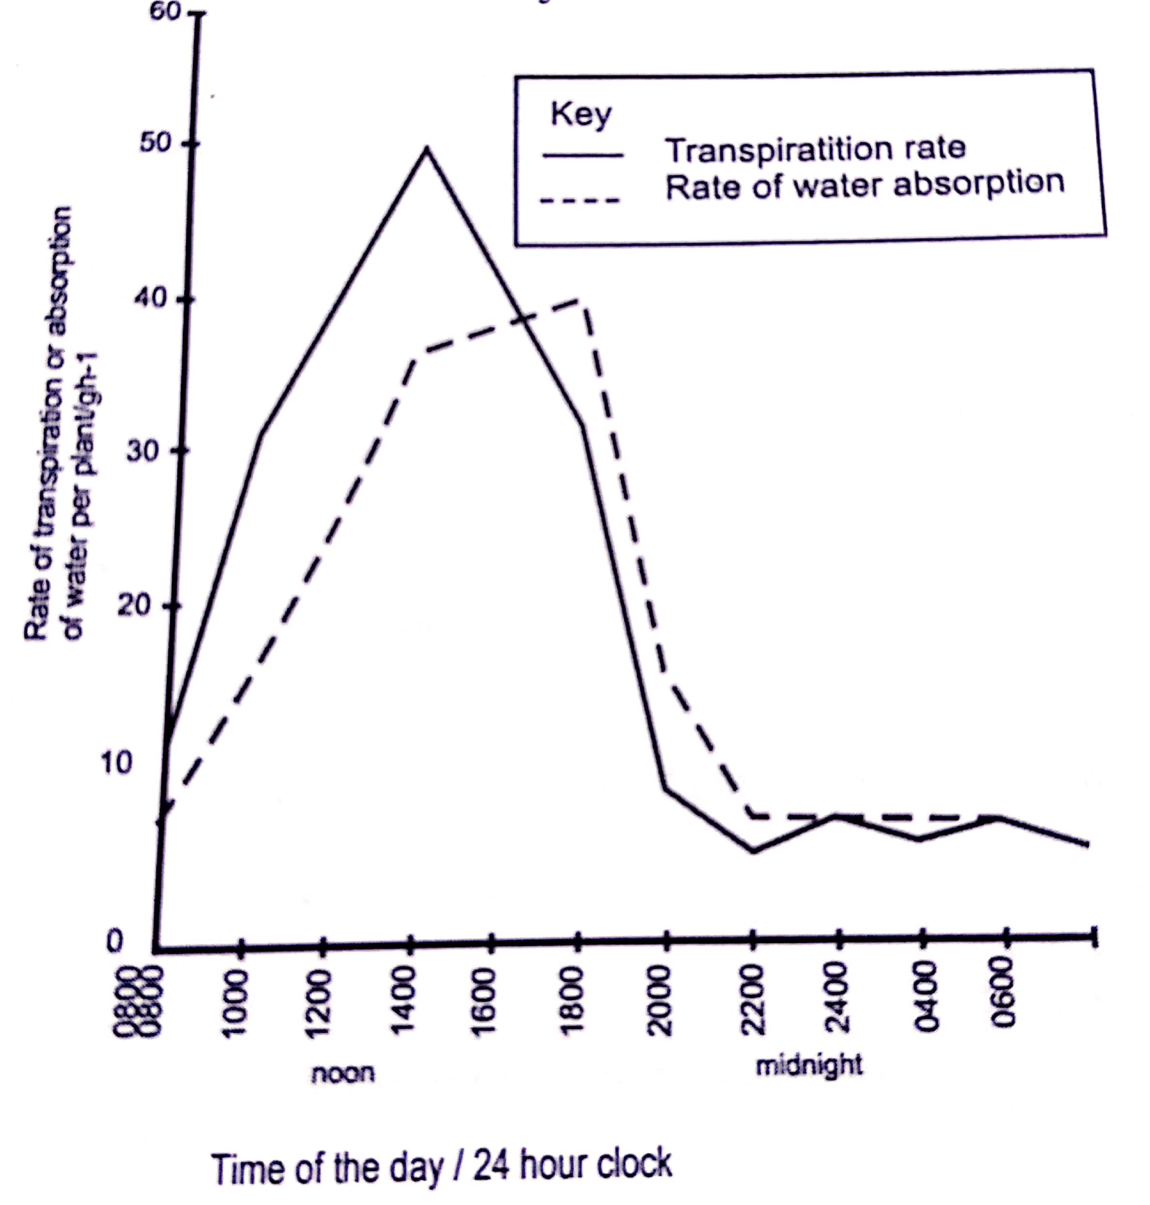

a) Describe the change in the rate of water absorption from 08:00hours to 20:00hours (03marks)
...........................................................................................................................
............................................................................................................................
...........................................................................................................................
............................................................................................................................
b) What are the differences in the changes in the rate of water absorption and the rate of transpiration from 08:00hours to 20:00hours (03marks)
...........................................................................................................................
............................................................................................................................
...........................................................................................................................
............................................................................................................................
c) Account for the changes in the rate of transpiration that took place between
i) 08:00hours to 14:00hours (04marks)
...........................................................................................................................
............................................................................................................................
...........................................................................................................................
............................................................................................................................
ii) 14:00hours to 20:00hours (04marks)
...........................................................................................................................
............................................................................................................................
...........................................................................................................................
............................................................................................................................
d) Explain the relationship between the changes in the rate of water absorption and the rate of transpiration (03marks)
...........................................................................................................................
............................................................................................................................
...........................................................................................................................
2. Shoots from two different species, A and B were placed in boiling tubes as shown below

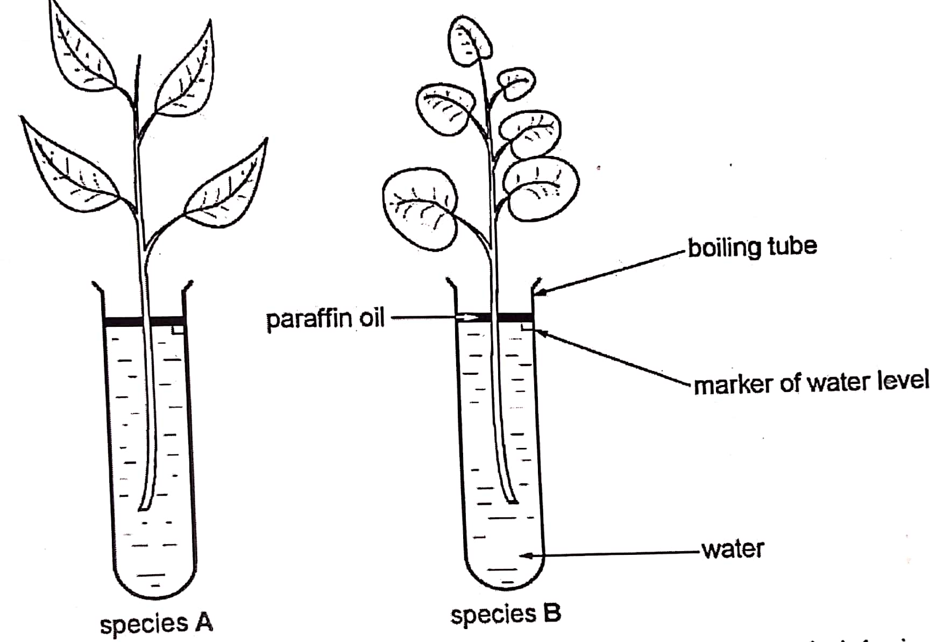
Both species were placed near an electric fan and a lighting bulb for 6hours and their masses were recorded at the end of the experiment in the table below

Species | Mass in grams (g)
Species | Initial | Final
A | 15 | 13.1
B | 15 | 11.4

a) Explain for the decrease in the mass of both species when placed under the electric fan (03marks)
...........................................................................................................................
............................................................................................................................
...........................................................................................................................
............................................................................................................................

b) Calculate the percentage difference in the loss of mass between the species A and species B.
i) Species A (1½marks)
...........................................................................................................................
............................................................................................................................
...........................................................................................................................
............................................................................................................................
ii) Species B (1½marks)
...........................................................................................................................
............................................................................................................................
...........................................................................................................................
............................................................................................................................
c) Suggest
i) two reasons for the difference in loss of mass between the two species (02marks)
...........................................................................................................................
............................................................................................................................
ii) the purpose of using paraffin in the boiling tubes (01mark)
...........................................................................................................................
............................................................................................................................
iii) the environmental conditions represented by the bulb and electric fun (01mark)
...........................................................................................................................
............................................................................................................................
3a) Distinguish between transpiration and wilting (02marks)
...........................................................................................................................
............................................................................................................................
b) Describe the effect of increasing the following factors on the rate of transpiration
i) Temperature (04marks)
...........................................................................................................................
............................................................................................................................
..........................................................................................................................
ii) Humidity (03marks)
...........................................................................................................................
............................................................................................................................
...........................................................................................................................
c) State any one role of transpiration to flowering plants (01mark)
...........................................................................................................................
............................................................................................................................
Section c
Attempt only two questions from this section
4a) Describe the forces that aid the movement of water from the soil into the leaves of the plant (10marks)
b) Give any 5 adaptation of root hairs to perform their functions (5marks)
5. Describe an experiment to show how the rate of transpiration is measured in plants
Good luck

